
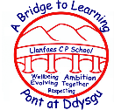
Llanfaes Newsletter/Cylchlythyr!
June/Mehefin 2026
Diary Dates/Dyddiadau’r Dyddiadur  Summer Term 2026  June/Mehefin  1st - Pupils return to school  5th – Year 6 – Cwis Cymru finals in Aberystwyth  8th – Welsh national tests week  12th Sports day  15th and 16th - Year 2 Brecon Choir Festival project  16th – School Open Morning to view Moster Phonics and Welsh  17th – Year 5 Brecon high School WOW Day  18th – Year 5 and 6 TAG rugby festival @Christ College  22nd – 23rd - Year 2 Brecon Choir Festival project  24th – 26th Year 6 Transition Days – Brecon High School  23rd – Year 3 and 4 Brecon Canal trip  July/Gorfennaf  3rd- School Grounds Day  6th – Reports to parents and  8th - Parent Consultation sessions  6th – 10th Year 6 Transition Days – Gwernyfed High school  10^{th-} No After School Club available  14th – Year 6 Leavers Concert @5pm  15th – Year 1 and 2 “Big Sing” @ Theater Brycheiniog 10am  15th – Whole school church service 1:30pm  16th – Last day of school  17th – INSET DAY  Katie Goes the Extra Mile!  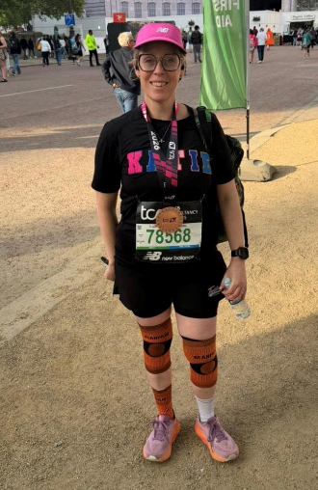  A huge congratulations and  thank you to Katie, who took  on the challenge of the  London Marathon and raised  an incredible amount£900  for Llanfaes School. Katie’s  dedication, determination  and hard work have helped  make a real difference, and  we are so grateful for her  amazing support. Every  mile she ran and every  pound she raised will help  us continue providing valuable  opportunities and experiences  for the children. | Attendance  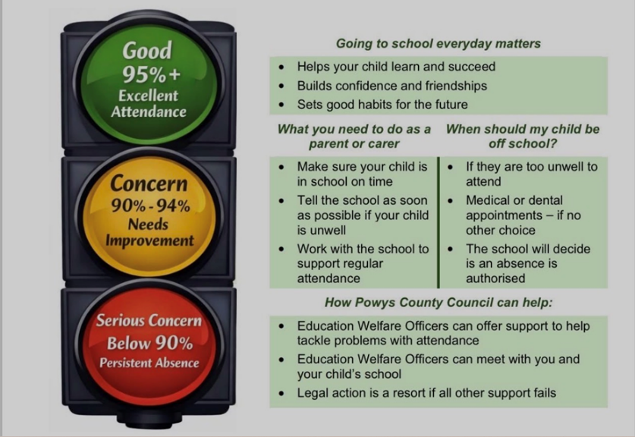  Your child’s attendance matters.
Camau Bach Flying Start
2+ provision – September 2026
We are delighted to announce that we will be offering Flying Start Childcare from 2026!
This fantastic programme will provide funded childcare and early learning opportunities for eligible families, helping children get the very best start in their learning journey.

📱 Scan the QR code to find
out more about Flying Start
Childcare, check your eligibility,
and learn how to register.
We look forward to
welcoming more families
to our setting in 2026!

Safeguarding Corner: Online Safety
As children spend increasing amounts of time online, it is important to regularly monitor their internet use and be aware of the apps, games, websites, and social media platforms they are accessing.
Please encourage a healthy balance between screen time and other activities. Spending time outdoors, being active, and engaging in family activities are all important for children's wellbeing and development.
We recommend:
• Monitoring what your child is doing online and who they are communicating with.
• Setting appropriate screen time limits.
• Keeping devices in shared family spaces where possible.
• Having regular conversations about online safety and responsible internet use.
By staying involved and informed, we can help children enjoy the benefits of technology while staying safe online.

The Royal Mint Cardiff  Our Year 5 and 6 children recently enjoyed an exciting visit to the Royal Mint, where they learned all about how coins are designed and made. They explored the history of money, discovered fascinating facts about coin production, and had the opportunity to see the minting process up close.  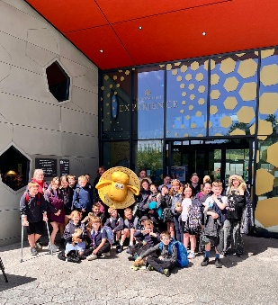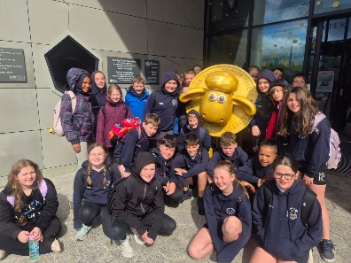 | Brecon Little Theatre  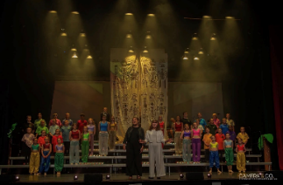  We are incredibly proud of all our children who took part in Brecon Little Theatre’s performance of Joseph last weekend. They demonstrated outstanding confidence and enthusiasm, putting on a truly memorable show.  Congratulations to all involved on a fantastic performance – you should be very proud of yourselves! | Beth Thompson  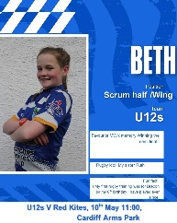Congratulations to Beth, who recently played at Cardiff Arms Park and helped the Mid Wales Kites win the Gwalia East Wales Matrix Bowl Final. What a fantastic experience and a wonderful achievement. We were also delighted to hear that some of her classmates were there to cheer her on alongside the Brecon Under-11 coaches. Well done, Beth.
A Huge Thank You! 💙  We would like to extend our sincere thanks for your incredible support with our recent fundraising events. Thanks to your generosity and enthusiasm, we have raised an amazing £2150 through recent events such as the £5 challenge Market place, Friends Bingo and the Reception Ramble.  Your support makes a real difference to the experiences and opportunities we can provide for our children, and we are extremely grateful.  As a result of the fantastic amount already raised, we have decided not to hold the Colour Run as part of Sports Day this year. While the event is always great fun, it is also a fundraiser, and we feel that you have already contributed so much. We do not want to keep asking our families for additional donations when you have been so supportive throughout the year. | Reggie Bowen  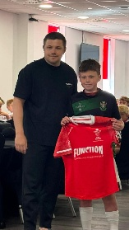  Congratulations to Reggie Bowen, who recently had the fantastic opportunity to play at Parc y Scarlets as part of the Welsh Schools Rugby Union's 50th Anniversary celebrations. What an amazing experience and a wonderful achievement! We are very proud of Reggie and hope he enjoyed every moment of this special occasion. | Princess Trust Charity    A huge congratulations to Lexi-Jay, who chose to support the Princess Trust by having her hair cut and donated. This is an incredibly kind and selfless act that will help bring confidence and happiness to children and young people experiencing hair loss. What an amazing thing to do for others!
Sports Day Friday 12th June  Our School Sports Day is just around the corner, and we are hoping for some good weather. Please look out for the letter and timetable that will come out via Schoop explaining a few changes to how this year’s sports day will run.    If anyone has a gazebo  they could lend us for  the event, please  let Mrs Roe know  in the office. | Year 5 and 6 Netball Tournament  A huge well done to both  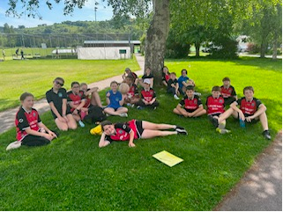  of our netball teams who  recently took part in the  tournament at Christ College.  The players demonstrated  excellent skills, teamwork,  determination, and  sportsmanship  throughout the afternoon.  We are incredibly proud of their positive attitude and the way they supported one another
Friends Bingo Success  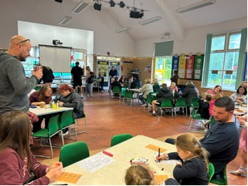  Thank you so much to  those of you who gave  up your Wednesday  evening at the end of  half term to come to  the Friends bingo.  There was pizza,  refreshments, bingo  prizes and a raffle. Lots of fun was had by all and the  event raised £232. Thank you to Mrs Lloyd and the FOLS for arranging the evening and Mrs Jackie Williams for bingo calling! | Year 5 and 6 Basketball and Football Festival  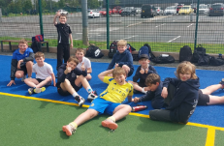  A huge well done to all the  children who took part in the  football and basketball  festival. It was wonderful to  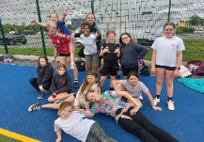  see so much enthusiasm,  teamwork, and enjoyment  on display throughout the  day. Most importantly, they  played with smiles on their  faces and represented the  school with pride. The Llanfaes A team will go on to play in Llanelli on the 22nd June. Pob lwc bawb!
This newsletter is available on our website www.llanfaes.powys.sch.uk

