Llanfaes Primary School

Prospectus

2026-2027
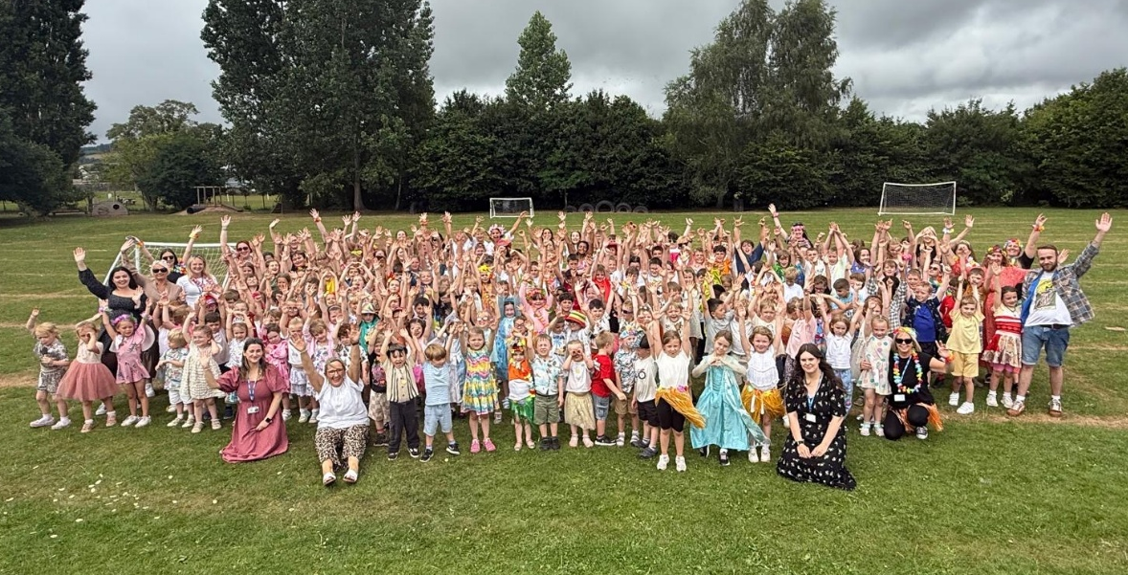

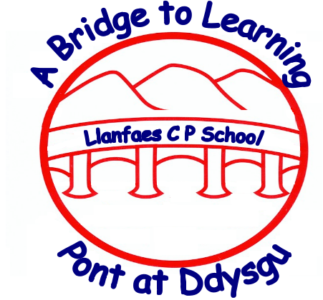

Email: office@llanfaes.powys.sch.uk
Tel: 01874623326
Head Teacher: Mrs C North
Chair of Governors: Mrs J Williams






Croeso/Welcome to Llanfaes Primary School.
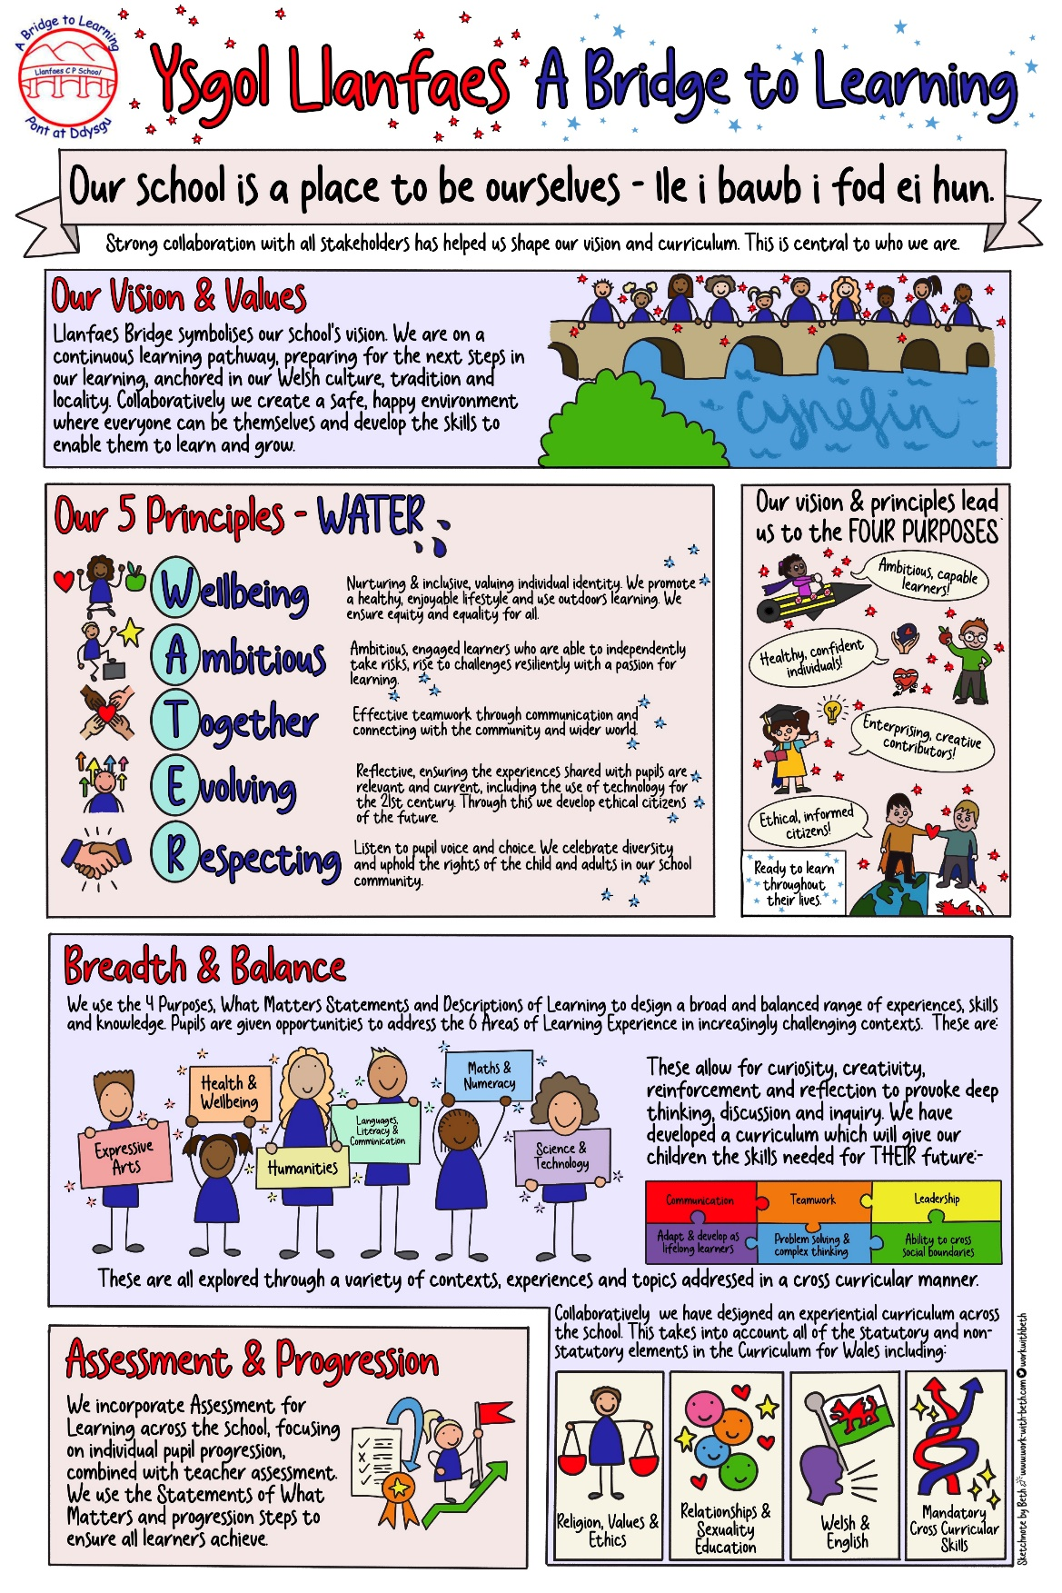
Thank you for taking the time to read our prospectus and child’s leaflet, written by our School Council. We hope that they will give you a brief introduction to our school vision and curriculum.

Our vision is supported by our WATER Principles.

W – well-being. Llanfaes School is nurturing and inclusive, valuing individual identity. We promote a healthy, enjoyable lifestyle and use of outdoor learning. We ensure equity and equality for all.
A – ambitious. Llanfaes School develops ambitious, engaged learners who can independently take risks, rise to challenges resiliently with a passion for learning.
T – together. Llanfaes School develops effective teamwork through communication and connecting with the community and wider world.
E – evolving. Llanfaes School is reflective, ensuring the experiences shared with pupils are relevant and current, including the use of technology for the 21st Century. Through this we develop ethical citizens of the future.
R – respecting. Llanfaes School listens to pupil voice and choice. We celebrate diversity and uphold the rights of the child and adults in our school community.

These five principles underpin our daily life at school and apply to everyone in our school community – pupils, staff, parents and governors. At Llanfaes we consistently endeavour to provide a welcoming and caring environment in which each individual is supported, encouraged and challenged to achieve his or her full potential. The happiness and security of our pupils is paramount at all times, as only when a child feels contented can they learn successfully. Academic, musical, social and physical achievements are celebrated and valued. We are a Community Primary school and an English medium school.
Expectations, for all individuals in our school community, are high and pupils develop the skills that will enable them to become independent, well- motivated, life- long learners. Particular talents in all areas are encouraged and developed and pupil’s individual needs addressed.
Our school positively maintains an open, inclusive community, readily welcoming parents and other family members to play an active part in school life. We strongly believe in developing a partnership of parents, staff and governors. Individually we can provide opportunities for our children but together we can achieve even greater success.
Our school encourages children to participate in a very wide range of opportunities from areas such as sport, music and environmental activities. In addition, we have close contact with many local organisations and our local community. At Llanfaes we develop in the children a pride and understanding of the locality, our heritage, environment and culture. We believe that collectively and individually we can make a positive difference.

Visits to the school are welcomed and can be arranged either by telephoning (01874623326) or e mailing office@llanfaes.powys.sch.uk.

Mrs C. North
Headteacher

CONTENTS
1. The School Building and Outdoor Environment
2. School Organisation
3. Home and School
4. Starting School
5. School Day
6. School Curriculum
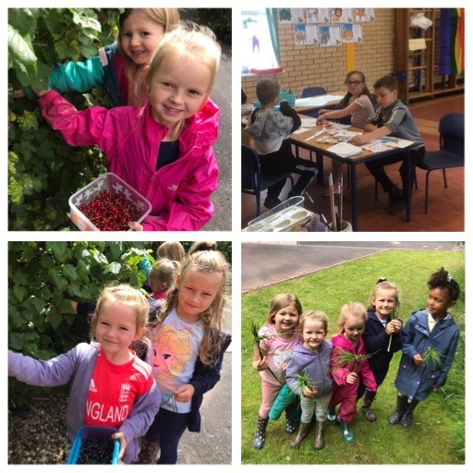
7. Special Needs
8. Reporting on Progress
9. Extra-Curricular
10. Educational Visits
11. Absence and Illness
12. Health and Safety
12. School Meals
14. Uniform
15. Discipline
16. Complaints
17. Transfer to Secondary School
18. Disability Access
19. Equal Opportunities

Appendix:
- School Calendar
- Staff
- The Governing Body
- LA
- Annual rates of Authorised and Unauthorised absences
- Accessibility Plan
- Registration Form

1.The School Building and Outdoor Environment
The school opened in May 2002 and is a purpose-built primary school catering for 240 pupils. The accommodation is spacious and purposeful. The hall is a multipurpose room, serving as an area for PE, assembly, dinner, performances etc. The classrooms open onto a connecting corridor with access to toilets, cloakrooms, and the outside. An internal- play area providing a safe and secure environment for our youngest children is at the heart of the school. The three-year-old setting, Little Steps – Camau Bach, has a separate purpose- built classroom and play area. School meals are provided and are cooked in the school’s kitchen.
The school grounds have been greatly enhanced to provide a variety of resources for outdoor learning for all ages. Designated environmental areas have been established with the support of agencies such as Brecon Beacons National Park and Wood U Believe It. These include an outdoor learning area called Gardd Tawel, Hobbit Houses and learning zones directly outside the classrooms in Year 1 and Year 2 and After School Club. These developments have been undertaken with the full involvement of pupils, parents, governors and staff. The school has substantial grassed areas and tarmac surfaces. In addition to outdoor learning activities these areas are also used for general play and PE including team games such as football, rugby, cricket, hockey, rounders and netball.
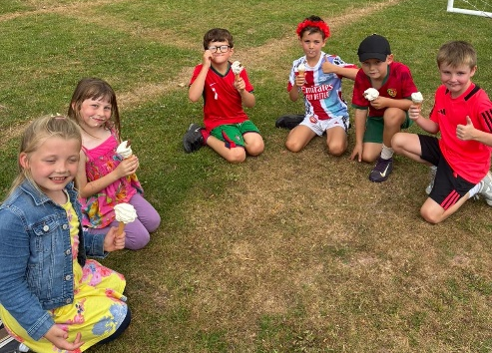
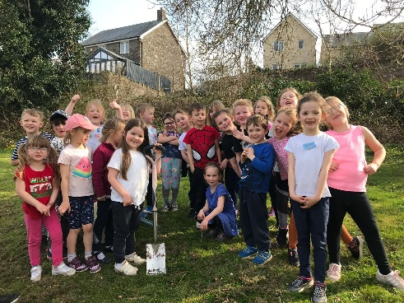

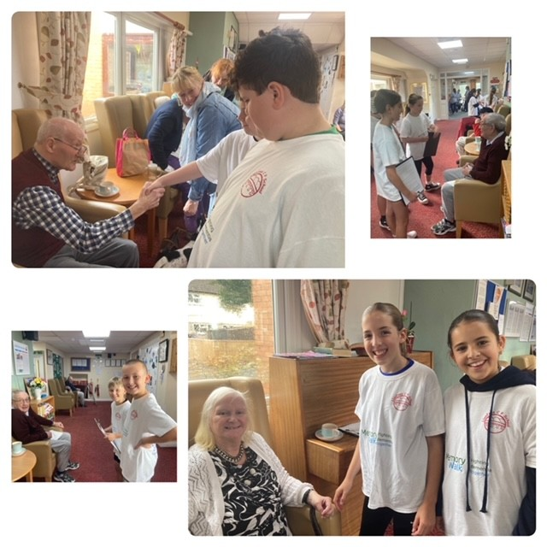
The school is proud to have achieved the Welsh National Quality Award for Healthy Schools and the Platinum Flag for Eco Schools twice. Llanfaes School was the first school in the region to be accredited as a 360 Safe Cymru Online Safe school and this has been successfully reaccredited. We are also a Fairtrade School. Our school is proud to be a Dementia Friendly School. Year 6 pupils plan and organise a Dementia Walk bi-annually to raise funds for the local Brecon Dementia Friend’s group and our intergenerational project includes weekly visits to our local residential home, Trenewydd.

2. SCHOOL ORGANISATION

The school caters for pupils between the ages of 4 and 11. At present the school consists of a Reception class, Year 1, Year 2, Years 3, Year 4, Year 5 and Year 6. Little Steps – Camau Bach is also available for 3-year-olds on the school site. The classes are organised on a single age basis. Transfer from one class to the next occurs at the start of the school year.

3. HOME AND SCHOOL

And when at last their task was done,
They looked at what they’d wrought.
The beautiful shape of the precious child,
Could neither be sold nor brought.
And each agreed it would have failed,
If one had worked alone.
For behind the parent stood the school,
And behind the teacher, home. (Anon)
We regard a close relationship between home and school as fundamentally important. The school cannot function effectively unless it receives the wholehearted support of the parents. Parents are requested to sign and support the Home School Agreement. Parents are encouraged to visit the school at any time to discuss their child’s/children’s progress. We are here to help. A close liaison between home and school is vital to ensure that pupils fulfil their potential. A “Home School Agreement” provides an opportunity for parents and pupils to adopt the principles and to show a commitment by signing a copy of the agreement. This includes several aspects including ensuring pupils attend regularly as repeated absence hinders learning. When pupils see their parents showing an interest in their schooling we notice the benefits to their attitudes, efforts and attainment.

Parent/Carer Forum
We also have Parent/Carer forum where parent/carer representatives from each year group meet half termly with the Headteacher to raise issues, be consulted on school policies and give their views. Minutes from these meetings are shared with all parents and carers via Schoop.


Friends of Llanfaes School (FOLS)
An active and very successful Friends of the School Association
provides the opportunity for parents to come together with staff
to participate in and support the school in a variety of ways throughout
the year. There is a FOLS (Friends of Llanfaes School) box in the foyer
where parents and friends can post suggestions and ideas if they are unable to attend meetings.

Classroom Support
A number of parents feel that they have the time and interest to become more directly involved in school. We appreciate the regular classroom support of a number of parents. Their role is that of voluntary, non-teaching assistants such as Reading Buddies. Any parent who feels that they can help in this way or can offer some other form of expertise should contact the school. An enhanced DBS check would be undertaken prior to commencement.

4. SCHOOL ADMISSION

Powys pupils may enter the school the September following their fourth birthday. There is one admission per year, at the discretion of the headteacher.
The school follows the Powys Admission Policy. Admissions are handled centrally. (Please contact Powys County Council or the school for the admission criteria (01597 826000.) The school is able to accommodate disabled pupils who are admitted under the Powys Admission Policy.
Prior to that time pupils between the ages of three and four years may access preschool education for up to a maximum of two and a half hours per day (funded) and extra hours per day paid for by parents. This is available through Little Steps – Camau Bach.
Parents are encouraged to visit the school with their children prior to formally starting school. Such visits provide the opportunity to become familiar with the school and to meet members of staff and other pupils. A Welcome Pack is provided, and this includes valuable information for parents of preschool children.

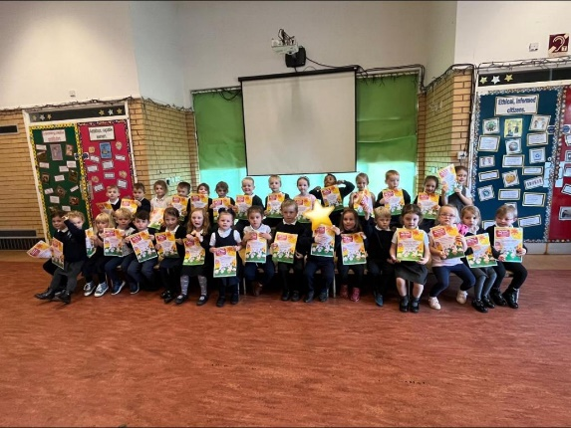
Home/School Links

We provide the opportunity for pre-school pupils and
their parents to come into school to share our facilities
and some activities. We hold Early Year Reading and
Numeracy events and Incredible Years “Ready for School”
workshops. Little Steps - Camau Bach and the Reception
class invite parents to a Nursery Rhyme Performance in
the Autumn term.

5. SCHOOL DAY

Breakfast Club 8:00am – 8:50am
Morning Session 9.00am - 12.15 pm
Playtime 10.40am – 10:55am
Afternoon Session 1.15pm - 3.15pm
After School Club 3:15pm – 5:30pm
- For health and safety reasons we ask that no children arrive at school before 8.50am. The school gates open at 8:50am and pupils in all classes enter school through their external classroom doors.
- It is essential that parents who drop off and collect pupils by car ensure that they park in the designated parking area and not in the bus bay for health and safety reasons. We also ask that parents use the car park responsibly at all times, and do not use the disabled parking bays nor the hatched emergency access area.
- Parents are asked not to enter the school building unless they need to see a member of staff, which they can do by going through the school gates to their childs classroom, or if your child is in reception speak to the class teacher at the main door.


6. SCHOOL CURRICULUM
We use the Curriculum for Wales and have created a bespoke curriculum for our children at Llanfaes which addresses their current and future needs. At the core of this is our drive towards the four purposes supported by the Areas of Learning. https://hwb.gov.wales/curriculum-for-wales/introductiont. We use the six areas of learning experience, what matters statements and progression steps to inform our planning. Parents may view any documentation in relation to the curriculum by contacting Mrs C North.
Our curriculum is broad, balanced and purposeful. Learning experiences are varied to ensure the needs of all learners are addressed. Central to our pedagogy is assessment for learning, ensuring continual progress for the pupils. We maintain a strong focus on well-being and outdoor learning throughout the school. Religious Values and Education and Relationships and Sex Education are key aspects of our curriculum also.

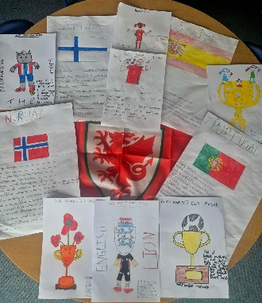
Curriculum Planning
The curriculum is planned to enable all learners to learn in the way and
at the pace that allows them to succeed. We promote inclusion and
engagement in learning, incorporating effective assessment techniques.

Year groups plan topics on a termly or half termly basis in order that the range
and skills can be imaginatively covered. In addition, some aspects of subjects
and specific learning skills may be covered in discrete teaching. This approach
ensures variety in learning experiences for the children and allows for individual
needs and interests to be catered for ensuring that children’s needs are addressed.

Welsh/Bilingualism
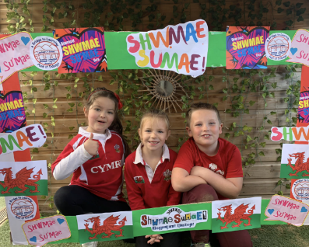
Welsh is taught as a second language. The importance of using the Welsh
Language in everyday life is emphasised as much as possible. Daily use of
incidental Welsh by introducing commands, phrases and questions occurs
throughout the school. The local authority scheme provides the basis of a
structured approach to developing the language. We aim to encourage the
use of the Welsh language as a means of everyday communication and to
develop an understanding of the specific cultural heritage of Wales. The
school has a ‘Criw Cymreig’ to enhance the use of Welsh and is working towards the Welsh Charter. The Charter inspires children and young people to use Welsh confidently and encourages the use of Welsh in social situations both inside and outside school. Our school has achieved the bronze and silver awards and is currently working towards Gold. Pupils are also involved in a range of language, sporting and Eisteddfod activities sponsored by the Urdd.

Relationships and Sexual Education
Relationships and Sexuality Education (RSE) is mandatory in Wales and at Llanfaes School it is integrated into our Curriculum for Wales planning. The aim of RSE is to ensure all learners, regardless of age, have access to age-appropriate education about healthy relationships, sexuality, and well-being, puberty, consent, and respecting diversity. Key aspects of RSE in Wales are:
Focus on healthy relationships:
RSE emphasizes the importance of building positive, respectful, and safe relationships with others. This includes learning about communication, empathy, and healthy boundaries.
- Sexual health and well-being:
Learners will receive information about sexual health, including puberty, contraception, and sexually transmitted infections.
- Consent and respect:
RSE will teach learners about the importance of consent in all relationships and how to respect diversity, including gender identity and sexual orientation.
- Empowerment and safety:
RSE aims to empower learners with the knowledge and skills they need to make informed decisions about their relationships and sexual health, while also protecting them from harm.
- Critical thinking and diverse perspectives:
Learners will be encouraged to critically evaluate information about relationships and sexuality, and to be aware of different viewpoints and experiences.
- Support and resources:
RSE will provide learners with access to information and support services related to relationships, health, and well-being.
- Parental involvement:
Parents have the right to withdraw their child from RSE, but schools are encouraged to engage with parents and address any concerns they may have.

7. ADDITIONAL LEARNING NEEDS
We adhere to the Additional Learning Needs Code for Wales, 2021. This can be viewed at www.gov.wales We regard all children as special and aim to give every child individual attention. If a child has specific gifts, learning or physical difficulties, these are all recognised and appropriate support given. We are an inclusive school and demonstrate equal opportunities for all. Additional Learning Needs are identified and monitored closely by staff, liaising with parents. The school has an appointed ALNCo, Mrs Thomas, who supports staff in addressing individual need. All classes have teaching assistant support, working with small groups or one-to-one basis. Close liaison with parents is vital together with outside agency support when necessary eg Educational Psychologist, Speech and Language. The school strives to address the needs of all groups of learners through careful monitoring of progress.
Children Looked After are supported and their achievement promoted through liaising with carers and other agencies. The Headteacher, Mrs C North is responsible for all Children Looked After in the school.
A copy of the policy regarding Additional Learning Needs is available from the school on request or on the school website.

8. REPORTING ON PROGRESS
PARENTS’ EVENINGS
Parents’ Evenings are held twice a year, in the Autumn and Spring Terms. Parents are also invited to make an appointment to discuss their child’s end of year report. In addition, ‘Welcome to the Class’ meetings are held at the beginning of the Autumn Term. These give an opportunity to learn about the specific requirements for that class eg timetables, PE, expectations, homework etc. The school actively promotes an open-door policy also, encouraging parents to email or speak with staff at any time if they have questions or concerns.
REPORTS
Full written reports are sent out each July prior to the Parents’ Evenings. Parents are encouraged to respond to the reports, copies of which are kept by the school to provide a permanent record of achievement.
TEACHER ASSESSMENTS
On-entry assessments are made by class teachers when pupils join the school. During the year teachers make on going assessments of pupil achievements to inform their planning and teaching. Standardised tests in reading and spelling are used during the year to monitor achievement. Welsh National tests in reading, numeracy and reasoning are completed in May each year and results sent out by Welsh Government before the end of the summer term. Parents are welcome to have any results for their child. School results and comparisons with national scores are included both in this document and in the Governors Annual Report to parents that is sent out in September of each year.
SAFEGUARDING
The school operates a thorough and comprehensive safeguarding policy to ensure the well- being of all of our children. This includes our Child Protection and Safeguarding Policy (available on the school website). All parents and carers should be aware that if the school has any concerns regarding a child’s safety, we will not hesitate to make a referral to social services. We will always put the child’s needs first.

9. SCHOOL CLUBS AND EXTRA CURRICULAR ACTIVITIES
There are clubs and activities that take place after school hours and during lunch breaks. These clubs or activities are open to all pupils, though some are age specific. They are organised or run by members of staff and some parent helpers who are all DBS checked and can therefore change from year to year. Regular times are arranged but there are occasions when teachers have to attend meetings or courses and clubs may be cancelled on particular days. After school clubs run from 3.30pm to 4.15pm (unless otherwise arranged) and parents have to make arrangements to collect pupils at the end of the session.
In addition, there is a thriving ‘After School Club’ held within the school which operates from 3.30 pm – 5.15 pm at a charge of £8 per session. Parents who may be interested in this facility should contact the school for further details. A Breakfast Club also operates from 8 am for £2.50.
Clubs and activities during the year may include:
Cookery Athletics Running Club Netball
Singing lessons are undertaken by any pupils in Brecon Cathedral Choir.

10. EDUCATIONAL VISITS
A number of educational visits are arranged during the year. Many are linked with the curriculum work of a particular class; others are organised on a whole school basis. Most visits take place within the school day, but a number are extended or are residential. Residential trips are organised on an annual basis, generally they are of three days duration.
March - Year 5 and 6 visit to the Urdd camp at Llangrannog. This is a Welsh Language and activity course.
June – Year 5 and 6 visit to Manor Adventure. Two-night residential trip.

CHARGING AND REMISSIONS
The funding for many visits or trips requires voluntary parental contributions, although in some cases the "Friends of the School" have made an additional contribution either partially or fully funding trips. The voluntary parental contributions sometimes include a non-refundable deposit, though as far as possible other monies will be refunded should a child be unable to take part in a visit. No child would be excluded if a parent decides not to make a voluntary contribution. Where too few voluntary pupil contributions are received, planned visits or trips may be cancelled. A copy of the school Charging Policy is available upon request.

11. ILLNESS AND ABSENCE

ILLNESS AND ACCIDENTS
In the event of illness or an accident at school we make every effort to contact the parent. Emergency contact details are vital, and we ask they are kept up to date. If this is not possible and we consider the illness or accident to be serious then we take the child to the doctor or the hospital.
MEDICINES
School staff can only administer prescribed medicines. Parents must complete a letter of permission. All medicines must be clearly labelled with dosage. Parents can, of course, come to school to administer medicines themselves.
ABSENCES
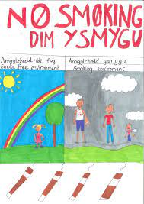
If your child is absent, please ring the school and leave a message on the absence line as early as possible in the morning, but before 10am. A reason for absence must be given. Where messages are not received, the school operates a ‘first day response’ system and will contact parents to confirm reason for a absence. An Unauthorised absence is recorded when no explanation is forthcoming from parents. Parents must complete a holiday absence form, and ten school days only are permitted. Above ten days it will be recorded as an unauthorised absence. Please remember that any absence, authorised or not, counts towards a child’s overall attendance rates. Late marks also accrue and are reflected in an attendance percentage for your child. Good attendance is vital for the continuity and progression of your child’s education. We aim for 95%+ attendance for every child. The attendance policy is available on the school website or on request from the school.

12. HEALTH AND SAFETY

The school is subject to the same safety rules as other public
buildings. The whole of the school building and grounds is a
non-smoking area which includes e cigarettes.
No dogs are allowed on school premises. In addition, we ask that all visitors to school enter through the main entrance and report their presence to the school secretary who will then provide them with appropriate authorised access to school. Visitors will be asked to sign a ‘Visitor Book’. School gates are locked after 9.05 am and re-opened at 3.10 pm. The gates are locked again at 3.30 pm. All staff and volunteers have current DBS enhanced checks. The school Health and Safety Policy is available on the school website.
There are toilet facilities for the younger pupils, older pupils, staff and a disabled toilet. There are also toilets in the Reception classroom and Little Steps classroom. All toilets are cleaned daily by cleaning staff.


13. SCHOOL MEALS
In Wales, all primary school children are eligible for universal free school
meals, regardless of their household income or benefit status. This means
that every child attending a primary school, receives a free, nutritious meal
every school day. Children who do not have school meals may bring a
packed lunch. To support our healthy school ethos we request that packed
lunches are healthy in nature, placed in a clearly marked container and
those drinks (preferably water) are brought in unbreakable bottles
or cartons.

Nut free School

At Llanfaes we aim to be a Nut-Free school. The school aims to
protect children who have allergies to nuts and help all our pupils
to take responsibility as to what foods we can eat and be aware
of where they may be put at risk. We do not allow nuts or nut
products in school lunch boxes.

14. UNIFORM

We have a school uniform, which although not compulsory, is generally worn by the majority of pupils. The uniform includes navy school sweatshirt or hoodie with school logo or navy jumper cardigan and:-

Winter Summer
Navy skirt/trousers Navy/white check dress Navy/black shorts & white White polo shirt
Year 6 pupils may purchase Leavers hoodies to wear as part of their school uniform at the beginning of their final academic year. You can order uniform bearing the school badge directly from the Prints Of Wales website - www.theprintsofwales.co.uk password: Llanfaesschool2019
Please label all items of clothing clearly with your child’s name. Items of jewellery are best left at home. Lost property is displayed at regular intervals, but children consistently fail to recognise their own clothing unless it is clearly marked.

P.E. KIT
Children can come to school dressed in PE kit on the day they have P.E. Appropriate P.E. clothing should include shorts or tracksuit bottoms (weather dependent) and T-shirt. Trainers are essential as PE takes place mainly outside. Key stage 2 pupils are likely to require appropriate games kit.

15. DISCIPLINE
The staff and governors have drawn up a Behaviour Policy, based on assertive discipline which identifies the expectations and procedures for developing a high level of self-discipline within the school. As a school we focus on the positive behaviours we want to see. We hope that the Policy provides a firm but fair structure for creating a happy, relaxed atmosphere which is conducive to learning and to the attainment of high standards of behaviour. It is important that relationships are built on trust and understanding. We are concerned about the wellbeing of all our pupils and wish to create an atmosphere in which each child feels safe and secure in the knowledge that any problems which may arise will always be attended to promptly, with appropriate degrees of sensitivity and firmness.

16. COMPLAINTS

We hope that difficulties that may arise between parents and school can be resolved through informal discussion. If you have concerns that relate to your child, the conduct of staff or Governors or our delivery of the curriculum, please contact us immediately to make an appointment with your child's class teacher.
If your concerns cannot be resolved through this meeting or, if in doubt, please contact the Headteacher immediately. If your concern remains unresolved and you wish to take the matter forward, the school has a formal complaints procedure that is always followed. This is available on the school website, in the school foyer or from the office.

17. TRANSFER TO SECONDARY SCHOOL
Close links have been established with Brecon High School. Year 6 pupils visit the High School on several occasions during the year, culminating in spending two days at the High School in July. Brecon High School staff visit the pupils prior to their transition day in July. A Year 6 Parents Meeting is held at the High School annually. Admissions to the secondary school of your choice are centrally organised. Where children are moving on to different comprehensives we liaise closely with those schools and adhere to their transition arrangements.

18.DISABILITY ACCESS
The school complies with arrangements for admission of disabled pupils as outlined in the Disability Discrimination Act (DDA)1995. The school has full disability access to all areas. Admission for disabled pupils will be in line with Powys admission procedures. Rails and ramps are provided throughout the school. There are disabled toilet facilities for adults and children. The school has an Equality Plan which includes an Accessibility Plan. The Accessibility Plan can be found in the appendices.

20.EQUAL OPPORTUNITIES
The principles of equal opportunities form an integral part of practice throughout all aspects of school life both within and outside the classroom. We are committed to offering equal opportunities regardless of race, culture, gender, academic ability, physical ability or class. Our school provides an environment that is free from social, sexual or cultural prejudice for all members of our school community. Our vision is to achieve an environment in which members of the school community can be respected as individuals and in which the varied experiences of the community can enrich the life of the school.

Thank you for taking the time to read our prospectus. In it we have tried to outline the major points of information about Llanfaes Primary School that will be of value to you as a parent. However, if there are any areas that you would like clarified please do not hesitate to contact the school – we are always happy to help.
Visits to the school are welcomed and can be arranged either by telephoning (01874623326) or e mailing office@llanfaes.powys.sch.uk.
Mrs Cath North
Headteacher

Appendix
- Local Authority (see below)
- School Calendar
- Staff and Class Structure
- The Governing Body

Local Education Authority
The school is maintained by Powys Unitary Authority
Contact with the L.A may be made through school or directly to: | Local information is available from:
Children Families and Lifelong Learning  Powys County Hall  Llandrindod Wells  Powys  LD1 5LG  01597826000 | The District Education Office  Neuadd Brycheiniog  Brecon  01874 612211

School Term Dates 2026-2027

Autumn Term 2026

- Tuesday 1 September 2026 to Friday 23 October 2026
- Half Term - Monday 26 October 2026 to Friday 30 October 2026
- Monday 2 November 2026 to Tuesday 22 December 2026

Non-pupil Days
Tuesday 1 September 2026 – Inset Day
Friday 2 October 2026 - Brecon Cluster Inset
Monday 5 October 2026 - Brecon Cluster Inset

Spring Term 2027
- Monday 4 January 2027 to Friday 5 February 2027
- Half Term - Monday 8 February 2027 to Friday 12 February 2027
- Monday 15 February 2027 to Friday 19 March 2027

Non-pupil days:
Monday 4 January 2027 – Inset Day
Tuesday 5 January 2027 – Brecon Cluster Inset

Summer Term 2027
- Monday 5 April 2027 to Friday 28 May 2027
- Half-term - Monday 31 May 2027 to Friday 4 June 2027
- Monday 7 June 2027 to Friday 16 July 2027

Non-pupil days:
Friday 18 July 2027 – Inset Day

Staff and class structure
The following staff and class structure has been approved by the Governing Body for the academic year 2025-26.
Class | No of Pupils | Staff | Curriculum Responsibilities
Headteacher |  | Mrs C North | Teaching & Learning/Designated Child Protection Officer /Health and Safety, Health and Wellbeing AOLE/School Council
Year 6 | 30 | Mrs A Morris  Mrs A Whitehead | Acting Deputy Headteacher/ ARR/SLT/Language, Literacy and Communication AOLE/BSL pupil voice group  O.6 Classroom support/0.4 HWB (Wellbeing and ELSA support)
Year 5 | 24 | Mrs M Purnell  Miss K Savage | Humanities AOLE/Global Goalkeepers and Playground Buddies  Fulltime classroom support
Year 4 | 29 | Mrs D Thomas  Mrs J Driscoll | ALNCo/Mathematics AOLE  Classroom Support/0.5 ELSA and Intervention support Y3 and Y4
Year 3 | 24 | Miss E Chambers  Miss R Price | Fulltime classroom support and intervention  3 days a week
Year 2 | 28 | Mrs D Evans  Mrs E Parry | Expressive Arts AOLE/Digital Directors  Fulltime classroom support
Year 1 | 27 | Miss C Jarman  Miss D Davies | Science and Technology AOLE/ Eco Committee  Classroom support 20 hours
Reception | 22 | Miss E Thompson  Miss R Gibson | SLT/Language, Literacy and Communication AOLE/Criw Cymraeg  Fulltime classroom support
PPA/Management time/ALN time |  | Miss S Jones (HLTA 0.4)  Miss A Crawford-Plane (HLTA 0.2) | Y3-Y6  Foundation Learning Classes
ALNCo |  | Mrs D Thomas
Little Steps/Camau Bach |  | Miss J Parry  Miss Pfieffer and Miss C Bailey | Leader of setting  Setting teaching assistants
Office Manager |  | Mrs B Roe
Instrumental Tuition |  | Mrs E Prosser | Piano

Caretaker/cleaning staff: Mrs Alison Jones, Mr Rob Thomas
Cook in charge: Mrs Stephanie Jenkins
Kitchen staff: Mrs Julie Davies Mrs Nikki Dunford
Midday Supervisors: Mrs O’Connor, Mrs Roe, Miss Price, Mrs Parry, Mrs Whitehead, Miss Savage, Miss Crawford-Plane

LIST OF GOVERNORS
Headteacher

Mrs C North

L.A. Governors: TERM OF OFFICE
Mr M Dorance May 2023 – May 2027
Mrs. Jackie Williams (CHAIR) Oct 2024 – Oct 2028
Mrs L Jenkins Oct 2024 – Oct 2028

Parent Governors:

Miss J McDonough Jan 2023 – Jan 2027
Mrs S Thorne Jan 2023 – Jan 2027
Mrs R Morgan-Heath Sept 2023 – Sept 2026
Mr A Davies Oct 2023 - Oct 2027

County Governor
Mr David Meredith April 2024 – April 2028

Community Governors:
Mrs S Lloyd Sept 2023 – Sept 2027
Mrs M Stroud Sept 2024– Sept 2028
Mrs K Edwards Sept 2022 – Sept 2026

Teacher Governor:
Mrs M Purnell Sept 2024– Sept 2028

Non-Teaching Staff Governor:
Mrs B Roe Sept 2023 – Sept 2027

Clerk:
Mrs B Roe
c/o Llanfaes C P School
Beilihelig Road
Brecon LD3 8EB
.

GOVERNOR ELECTIONS
Parent Governor and Community Governor Elections will be held in Autumn Term 2026.

ACTIONS
There were no resolutions from the previous meeting.

Absence Target
The school aimed to achieve 93% attendance in 2025/26. The actual attendance was 94.3%. Llanfaes school attendance remains above the average for Powys and the Cluster schools. In order to achieve this in addition to the ‘first day response’ system and text messaging parents also when no reason for absence is received the school sent out information regarding the effect of absence on learning and termly letters to all parents informing them of their child’s percentage attendance. The headteacher works with the Authority to try and raise attendance and the Educational Welfare Officer wrote or visited pupils whose attendance was at 85% or below.

SCHOOL ATTENDANCE INFORMATION

The number of pupils on the school roll in September 2025 was 188
The end of year school roll was 191. NB For the purposes of attendance children in Reception and Nursery are not included.

Overall attendance rate (%) 94.3% (64812 actual attendances)
{ 2024- 2025 school year)

